Chapter 13, Problem 93.

A four-winding transformer (Fig. 13.144) is often used in equipment (e.g., PCs, VCRs) that may be operated from either 110 V or 220 V. This makes the equipment suitable for both domestic and foreign use. Show which connections are necessary to provide:

(a) an output of 14 V with an input of 110 V,
(b) an output of 50 V with an input of 220 V.

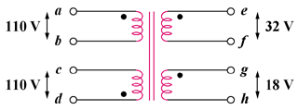

Figure 13.144
For Prob. 13.93.

